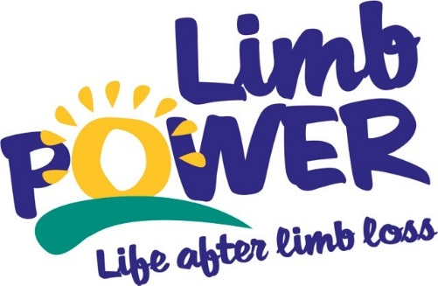

News Release
15th March 2017
Issued by LimbPower
For immediate release
LimbPower offers double sporting fun for young people in 2017
National charity, LimbPower is pleased to announce they will host two events for young amputees and children with physical impairments in 2017. On Saturday 24 June, LimbPower will bring the Junior Games to Birmingham - a new date on their sporting calendar. Then on Saturday 30 September the Games return to Stoke Mandeville Stadium in Buckinghamshire. For many years, the LimbPower Junior Games has provided children and young people with a great opportunity try out new sports and activities in a fun, friendly and supportive environment. LimbPower is delighted to expand their events programme this year and take the Junior Games to Birmingham for the first time.
The Games are open to children and young people aged five to eighteen with a physical impairment. Sports and activities on offer this year will include climbing, wheelchair basketball, track and field athletics, cycling, sitting volleyball, tennis, archery and football (subject to change). For many participants, the Junior Games is one of the first opportunities they have to try out lots of different activities.
Debbie, mother of Junior Games participant said:
“The Junior Games is such a confidence booster for Anna. She’s made friends and learned sports she would ever have tried without it. It’s even inspired her to join an athletics club.”
Chief Executive of LimbPower, Kiera Roche said:
“Expanding the Junior Games is part of LimbPower’s plan to reach more children with an amputation or limb impairment across the country, giving them an opportunity to try new activities in a safe and friendly environment amongst their peers.”

This year’s Junior Games events are proudly supported by Douglas Bader Foundation, Leigh Day, Ottobock, Dorset Orthopaedic and Axis (powered by Ottobock). Event details are as follows:
- Saturday 24 June - LimbPower Junior Games Birmingham, at Small Heath Wellbeing Centre.
- Saturday 30 September - LimbPower Junior Games Stoke Mandeville, at Stoke Mandeville Stadium.
More for information about the LimbPower Junior Games 2017 please visit www.limbpower.com or contact Andy Brittles, LimbPower National Sport Development Officer. Email andy@limbpower.com or call 07503 030702.
LimbPower’s vision is to change lives through the power of sport, physical activity and the arts. The Junior Games support their ongoing work to increase the number of suitable and available activity opportunities for people with limb impairments in the UK.
For more information about LimbPower, visit www.limbpower.com.
ENDS
Notes to editors
LimbPower
LimbPower was launched in November 2009 to engage amputees and individuals with limb impairments in physical activity, sport and the arts to improve quality of life and to aid lifelong rehabilitation.
In July 2014 LimbPower became a National Disability Sports Organisation, sitting alongside WheelPower, Cerebral Palsy Sport (CP Sport), Dwarf Sport, British Blind Sport (BBS), UK Deaf Sport, Mencap Sport and Special Olympics Great Britain (SOGB). Through this association and our work with the English Federation of Disability Sport and Sport England LimbPower help amputees and people with limb impairment engage in physical activity and reach their potential. LimbPower also run arts based activities including confidence workshops and a photography club.
The Charity’s mission is to engage amputees and people with limb impairments in regular and sustained participation in recreational and competitive sport and the arts, to improve their quality of life and aid physical, social and psychological rehabilitation. LimbPower aim to put each amputee and limb impaired person in touch with the right sport and leisure activity for their needs and ability.

