Manic MaraFun 9th July 2016
Joining instructions

Venue
The Manic MaraFun is at Stoke Mandeville Stadium, Guttman Road Aylesbury, Bucks, HP21 9PP. http://www.stokemandevillestadium.co.uk

The event stars at 9.00am on the athletics track and is due to finish at 4.30pm. Registration for the event is on the athletics track. 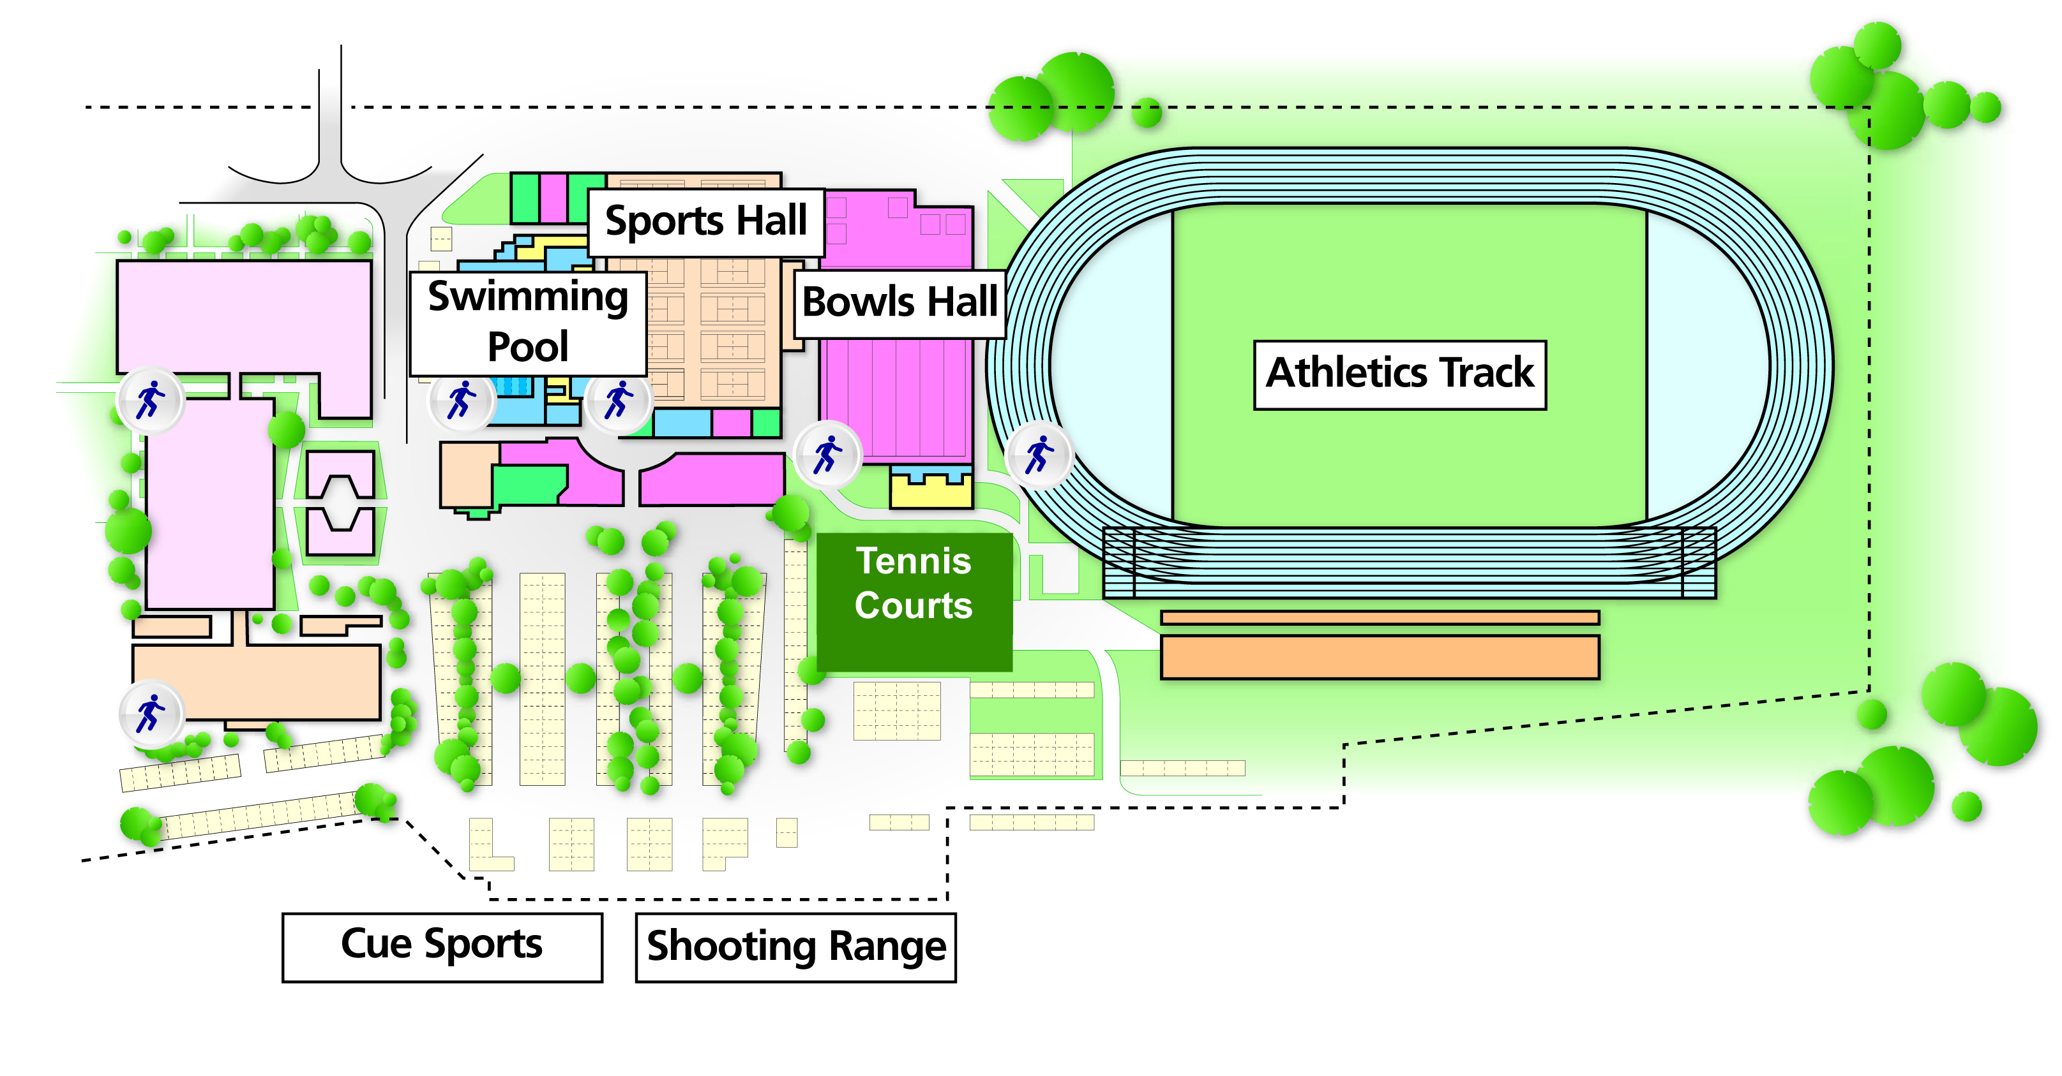

There is plenty of parking at the venue. Once you have parked please give your registration number to the staff at the leisure centre reception in front of the sports hall and then make you way to the gazebo on the athletics track for registration. Kiera Roche, Damian MacDonald and Andy Brittles are your onsite contacts from LimbPower.

Accommodation
If you are travelling more than two hours to reach the venue, we recommend that you stay at the Olympic Lodge or another local venue. LimbPower can book this for you. If you have committed to fundraising £50 or more LimbPower will pay for your accommodation

Catering
Snacks, water and a packed lunch will be provided for all participants taking part in the event.

Running Order

LAP NUMBER | LAP START TIME | STYLE
1 | 09:00 | RUNNING
2 | 09:15 | SCOOTING
3 | 09:35 | WALKING FORWARDS
4 | 09:55 | YOMPING
5 | 10:15 | ELECTRIC SCOOTER
 | 10:35 | RUNNING CHILDREN’S LAP
6 | 10:40 | HOOLA HOOPING
7 | 10:50 | HANDCYLING
8 | 11:10 | RELAY (WITH BATTONS)
9 | 11:30 | CRUTCHES
10 | 11:50 | WALKING BACKWARDS
11 | 12:10 | HOOPING/BATTON TWIRLING
 | 12:30 | CYCLING CHILDREN’S LAP
12 | 12:40 | BOUNCING A BASKETBALL
13 | 13:00 | WHELLCHAIR PUSH
14 | 13:20 | THROWING A RUGBY BALL
15 | 13:30 | CYCLING ADULT
16 | 13:40 | WALKING SIDEWAYS
 | 14:00 | CHILDRENS LAP SCOOTING
17 | 14:10 | DANCING
18 | 14:30 | KICKING A FOOTBALL
19 | 14:50 | WHEELCHAIR RACING CHAIR
20 | 15:10 | THREE LEGGED RACE
21 | 15:30 | SKIPPING
22 | 15:50 | WALKING SIDEWAYS
23 | 16:10 | PASSING A NETBALL
24 | 16:20 | PASSING A VOLLEYBALL
25 | 16.30 | CHILDREN’S LAP
26 | 16:50 | EGG AND SPOON RACE
26.6 | 17:00 | CONGA

Dress Code
You can take part in your sports wear or join in our fancy dress theme which is Star Wars and Space. Due to British weather we would recommend that you bring both sun cream and an umbrella.

Contact details
Please call Kiera Roche on 07968760001 or email: kiera@limbpower.com f you have any questions.

Manic MaraFun on social media

Twitter hashtag #ManicMaraFun @limbpower
Facebook page https://www.facebook.com/TheManicMaraFun/
Facebook event page https://www.facebook.com/ManicMaraFun/

Venue Contact Details:
Stadium Olympic Lodge
Tel: +441296 484848 Tel: +441296 461121

